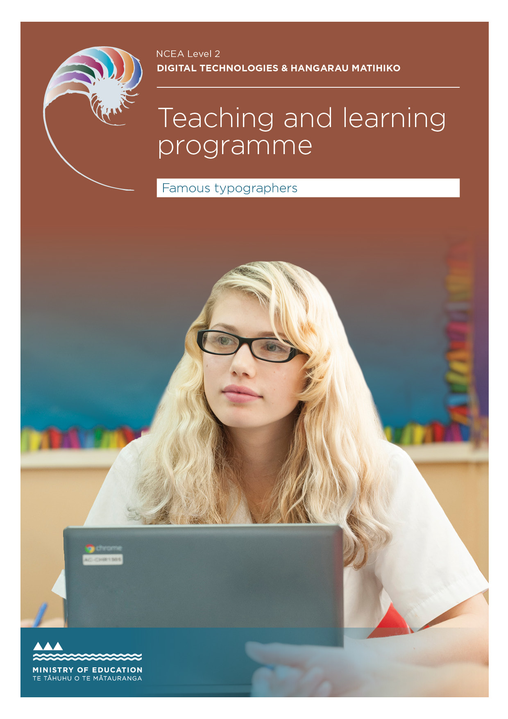

Developed by: Cathy Bourke, Hillcrest High School
External links to websites
The Ministry of Education does not accept any liability for the accuracy of information on external websites, nor for the accuracy or content of any third-party website accessed via a hyperlink from this resource. Links to other websites should not be taken as endorsement of those sites or of products offered on those sites. Some websites have dynamic content, and we cannot accept liability for the content that is displayed.
Front cover image: copyright © Crown. Page 8 image: by Pixabay, geralt copyright
© public domain

Published 2019 by the Ministry of Education PO Box 1666, Wellington 6011, New Zealand
www.education.govt.nz All rights reserved Copyright © Crown 2020

Summary of the teaching and learning programme
This programme teaches students the fundamentals of understanding and applying typography within print production. Through a series of tasks using publishing software, students will demonstrate specific technical skills with print and type to produce an eight-page booklet on a famous typographer.
The context of the booklet may be changed, but teachers should ensure that students have an understanding of type pioneers.
Students will need access to image manipulation software and desktop-publishing software. For this particular resource, Adobe InDesign and Adobe Photoshop have been used. (Alternative software may be used.)

By the end of this teaching and learning programme, students will be able to:
- produce high-quality print publications
- understand print and type conventions used in the publishing industry
- be creative and produce work for a specific audience
- construct digital media outcomes that integrate media types and incorporate original content.

Duration
This programme should take 32–40 hours (approximately 1 term).

The big ideas
A background in typography and well-known practitioners will allow students to design aesthetic and functional pieces that target audiences more directly. Learning specific publication software and processes used in industry will set students up with a strong base knowledge for future careers in print
or digital media.

Alignment to the New Zealand Curriculum
DTHM – Designing and Developing Digital Outcomes: Progress outcome 5
Students investigate digital media outcomes focusing on typography within each outcome.
Students are able to identify type issues and propose alternative solutions. They independently apply an iterative process to design, develop, and test digital outcomes that enable their solutions, identifying, and
responding to relevant social, ethical and end- user considerations. They use information from testing and, with increasing confidence, optimise tools, techniques and procedures to improve the quality of the outcome. They apply evaluative processes to ensure the outcome is fit-for- purpose and meets end-user requirements

Links to other learning areas
Design and visual communication (potential assessment AS91337 Use visual communication techniques to generate design ideas).

Teaching and learning pedagogy
Teacher guided activity-based learning. Students will be guided through the design and development process, including software, testing, feedback and iterative processes with
students constructing their own meaning through hands-on activities.

Prior knowledge and place in the learning journey
Students will need to have some knowledge of:
- digital literacy skills
- carrying out self-evaluation
- reflecting on inquiry practice
- being able to present information in a well structured, clear and concise format.
Resources required
- Adobe InDesign
- Adobe Photoshop
- Printing facilities
- Supplied resource bundle including: type PowerPoints, InDesign tutorials. These resources are available here.

How might you adapt this in your classroom?
Resources can be easily adapted based on the students’ skill set. If students already have a strong understanding of InDesign, the learning time can be cut down or altered to suit.

Assessment
Digital Technologies - AS 91893 Use advanced techniques to develop a digital media outcome.
This programme can be adapted to include AS91891- Apply conventions to develop a design for a digital technologies outcome.

Outcome
- A high-quality 8-page booklet on chosen typographer (InDesign file and printed hard copy)
- Documentation of process and techniques.

TERM OUTLINE

Specific learning outcomes (may include what will be covered) | Duration Assuming there are 4  1-hour lessons  a week. | Learning activities | Resources provided
Typography overview  What is typography? What are the different styles of type? | 3 lessons | - As a class or individually:  - watch The History of Typography  Task 1: Students should be directed to ‘a crash course in typography’ website to gain an understanding of the different types of typefaces.  Task 2: Students should do further research to answer the typography worksheet.  Teacher note: Students could read Butterick’s Practical Typography for homework.  2 & 3. As a class go through The Anatomy of Typography website  Task: Students should pick two fonts from the same font family and do their own anatomy comparison between the two. This can be in any software or by hand.  Teacher note: Students could watch Typefaces: An Animated Infographic Guide for homework. | The History of Typography  A crash course in typography Typography worksheet Butterick’s Practical Typography The Anatomy of Typography  Typefaces: An Animated Infographic Guide
Famous typographers  Who are pioneers of type and where has their work been used? | 2 lessons | Task: Students are to research one famous type practitioner, looking at their style and answer:  Why they are famous? Where is their work used? etc. Students should present to the class so the class gains a range of knowledge.  Teacher note: These presentations can all be placed into a padlet or online journal for class members to access. | Google doc for recording answers (or alternative as suggested in teacher note).

Specific learning outcomes (may include what will be covered) | Duration | Learning activities | Resources provided
InDesign tutorials  Learning the software.  Students will learn the basic setup of InDesign looking at print conventions:  - basic setup  - guides, griditures design  - links  - master pages  - kerning  - leading  - alignment  - paragraph styles  - character styles. | 2 lessons | Cover Print Layout Guidelines PowerPoint Cover the initial InDesign overview Tutorial  - initial page layout (tools)  - set-up – A5  - bleed – 3mm  - margins  - using text, columns  - using shapes, line  - alignment.  Task: Students set up a two-page spread to the determined measurements. They find one example of a magazine layout they like and try to replicate it using placeholder text. | Print Layout Guidelines – PowerPoint InDesign Overview tutorial  Placing and Flowing text in InDesign  – tutorial
 | 2 lessons | Cover:  - how to work with links  - master pages.  Task: Students should produce two more spreads demonstrating links and master pages. All links should be the correct colour mode and resolution for print. | Links – tutorial  How to Edit and Apply Master Pages  – tutorial
 | 2 lessons | Type – Class activity  Print out a range of text size comparisons. Have students comment on what font size they think each one is. This gives students a visual comparison of what text sizes actually look like printed out.  Watch the Leading, Tracking and Kerning tutorial  Task: Students complete the paragraph styles task. They should be incorporating all prior skills. | Leading, Tracking and Kerning – video Paragraph styles – task

Specific learning outcomes (may include what will be covered) | Duration | Learning activities | Resources provided
Testing procedures and data integrity  - copyright  - data integrity  - publishing, saving. | 2 lessons | Data integrity – Class discussion: How could you test your work? InDesign specific testing  - Preflight  - Spell check | Checking Your Document with Preflight Panel – tutorial  How to Package in Design Files – Tutorial
Relevant implications | 1 lesson | Students’ task: Copyright worksheet  Class discussion: What do we mean by relevant implications? What are relevant implications within print design and publishing?  Class discussion: What are relevant implications for end-users?  How do we explain these implications and then show how to address them? | Copyright worksheet
Begin assessment 4–5 weeks
Students should download and use the Resource Template_Booklet Design_Documentation to help guide them.

ASSESSMENT TASK : FAMOUS TYPOGRAPHERS

Curriculum key concepts | DTHM – Designing and Developing Digital outcomes: Progress outcome 5
Achievement standard(s) | 91893 Use advanced techniques to develop a digital media outcome
NCEA Level | 2
Credits | 4
Learning time guidance | 4 weeks for learning, approx. 16 hours  4–6 weeks for assessment, approx. 16–24 hours
Due date | Teacher to insert

Achievement criteria

Achieved | Merit | Excellence
Use advanced techniques to develop a digital media outcome. | Use advanced techniques to develop an informed digital media outcome. | Use advanced techniques to develop a refined digital media outcome.

ASSESSMENT TASK : FAMOUS TYPOGRAPHERS

Introduction

You will produce a booklet based on a typographer’s style, pieces of their work, and a brief history of their life. The overall look and design of the booklet should represent the chosen typographer.

What you need to think about before you begin this assessment:
You should reflect on the design process and design principles or elements as these will help develop the functionality and aesthetics of your outcome.

Tools and techniques could include:
placeholder text, spell check, alignment tools, smart guides.

Efficient tools and techniques (software specific) could include:
master pages, paragraph styles, preflight, colour swatches, links.

Testing procedures could include:
mock-ups, gaining relative feedback, checking for data errors, testing fonts, testing different colour combinations, testing different compositions.

Data integrity could include:
checking information is legible, accurate and copyright-free, images are the correct resolution and colour mode, files or folders are appropriately named and ordered.

Print conventions include:
bleed, margins, correct resolution, correct colour mode.

Type conventions include:
kerning, leading, linked text, columns, paragraph styles, character styles, text alignment, hierarchy.

Relevant implications:
You will need to identify and explain the most relevant implications. These could include an explanation on why your outcome should be: socially and/ or culturally acceptable, legal in terms of ethical and intellectual property

Your task:
obligations, aesthetically pleasing and functional, accessible, and considerate of end-users.
You should show how you have addressed or applied these implications.
Iterative improvement:
You will use an iterative process throughout the design, development and testing stages to improve your design and produce a high-quality outcome. This can be thought of as working in small cycles of the design
process for each stage to design, refine, test and evaluate to improve your outcome. You will need to be able to either summarise this process or show proof of it.
Your final outcome will be an 8-page A5 booklet.
Your booklet must show a cohesive design and include a mixture of images and information.
Follow these end-user specifications:
  - Size must be A5 (pages will be set up with a 3mm bleed.
  - 8 pages including cover and back.
  - Colour: CMYK, and resolution: 300dpi.
  - Binding: your 8-page booklet will be saddle-stitched.
  - Your work must reflect your typographer’s style.
  - Your outcome must be of a high standard (completed, trimmed, correct binding, correct grammar).
  - You are to have NO index page.
  - All text must be legible.

ASSESSMENT TASK : FAMOUS TYPOGRAPHERS

What you need to do (follow these steps):
What you need to hand in:
- all documentation
- printed A5 booklet
- InDesign file – packaged.
Stage 1: Prepare (not assessed but necessary to produce a high-quality booklet)
- Research a chosen typographer.
- Establish the purpose of your booklet and the end-user – produce a conceptual statement.
- Develop concepts, font options, colour combinations.
- Source information and images.
- Explain relevant implications.

Stage 2: Create

- Create concepts within the chosen publishing software.
- Prepare images in Photoshop with correct colour mode and resolution.
- Use relevant type and print conventions.
- Apply appropriate testing procedures.

You will use an iterative process throughout the design, development and testing stages to improve your design and produce a high-quality outcome. This can be thought of as working in small cycles of the design process for each stage to design, refine, test and evaluate to improve your outcome.
You will need to be able to either summarise this process or show proof of it.

Use this template to help you document your work – Resource Template_ Booklet Design_Documentation
Review this website for effective type practices – Effective Type Principles

ASSESSMENT SCHEDULE
AS91893 USE ADVANCED TECHNIQUES TO DEVELOP A DIGITAL MEDIA OUTCOME
Programme 1: Famous typographers Credits: 4

Final grades will be determined on a holistic judgment of the evidence against the achievement criteria.

CRITERIA | JUDGMENTS | COMMENTS
using appropriate tools and techniques for the purpose and end-users | The student has:  - identified end-users and the purpose of the outcome  - used Photoshop and InDesign to create their document and used some of the built-in features.
applying appropriate data integrity and testing procedures | The student has:  - used relevant software related checking processes  - evidence that testing has occurred. For example a briefly annotated screenshot  - checked information is accurate before using it in their booklet and ensured images are copyright-free or used appropriate referencing  - shown how data integrity was applied. For example data integrity is the accuracy of the information and the relevance to the end user and purpose.
using relevant conventions for the media type | The student has used the following:  - print conventions (summarised or shown via screenshots or other)  - colour mode is used (CMYK)  - resolution of images is 300ppi  - correct file types  - correct set-up with margins and bleed.
explaining relevant implications. | The student has included a paragraph which explains what the implications are, how they are relevant to the outcome and what is needed to meet each implication in the outcome, eg, ethical, usability, aesthetic, end-user considerations (refer to brief for more).

ASSESSMENT SCHEDULE
AS91893 USE ADVANCED TECHNIQUES TO DEVELOP A DIGITAL MEDIA OUTCOME
Programme 1: Famous typographers Credits: 4

CRITERIA | JUDGMENTS | COMMENTS
using information from testing procedures to improve the quality of the outcome | The student has documented changes made throughout the development process, which are recognised as improvements to the outcome. (Such things could include end- user feedback, ongoing refinement through mock-ups and trialling, links to research, etc).
applying relevant conventions to improve the quality of the outcome | The student has used type conventions, such as:  - hierarchy of text  - linked columns
 | - text wrap
 | The student has used design conventions, such as:
 | - design elements
 | - design principles
 | The student has used print conventions, such as:
 | - bleed
 | - margins
 | - correct image resolution
 | - correct colour mode for print
 | The student has documented why these conventions were used and how they have
 | enhanced the outcome.
addressing relevant implications. | The student has made specific changes and acknowledgments to meet relevant implications. These have been documented and are clearly evident in the final outcome.

ASSESSMENT SCHEDULE
AS91893 USE ADVANCED TECHNIQUES TO DEVELOP A DIGITAL MEDIA OUTCOME
Programme 1: Famous typographers Credits: 4

CRITERIA | JUDGMENTS | COMMENTS
iterative improvement throughout the design, development and testing process to produce a high-quality outcome | The student has evidence to show cycles of improvement based on testing or trialling. The student has produced a high-quality outcome.
using efficient tools and techniques in the outcome’s production. | The student has used specific tools and has evidence to show the effectiveness and efficiency of each:  - master pages
 | - paragraph styles
 | - Preflight.
 | Additional possible efficient tools:
 | - guides
 | - alignment tools
 | - swatches
 | - custom templates
 | - libraries

